Sustainable Supply Chain Performance Dashboard using Power BI

Name – Vitthal Gautam

Step 1 : Load the .csv file into Power BI by clicking the option ’Import data from excel’and select the file you want to import

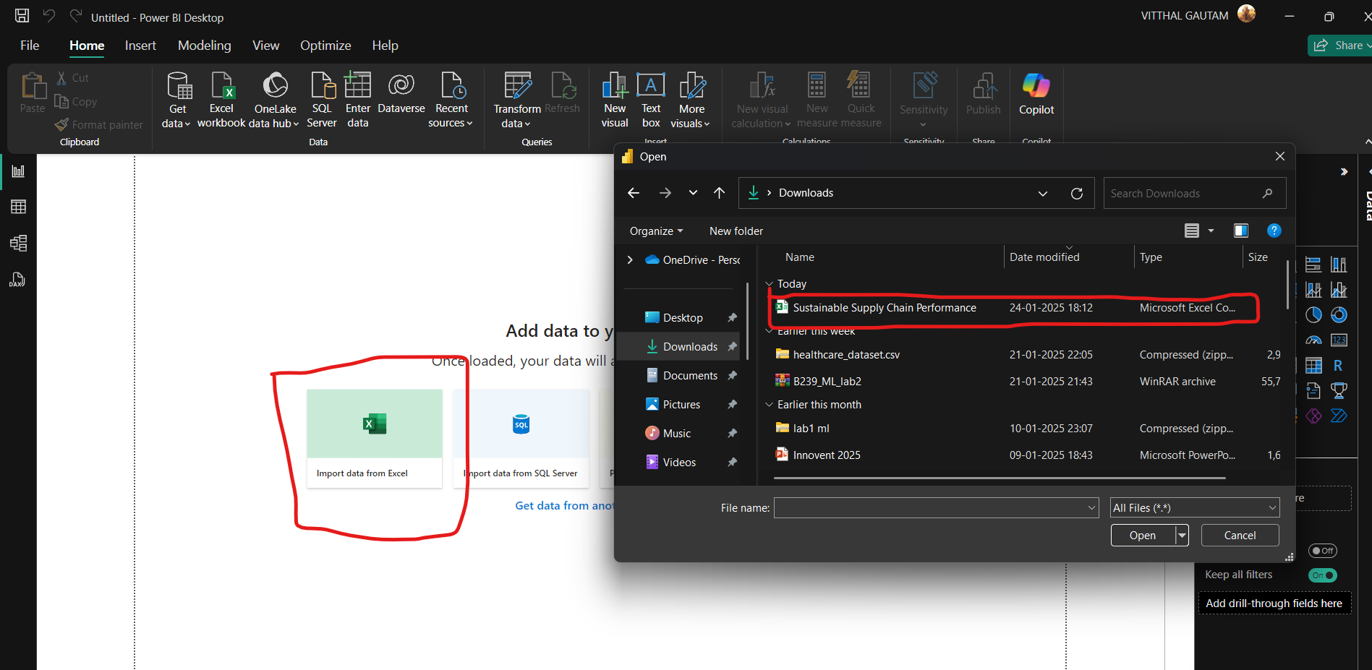

Step 2 : We can transform data by clicking on Transform data option on the HOME tab. Now on the new window click on the view tab where a checkbox named column quality is present. After clicking on column quality option Power BI shows the error and empty percentage of each column

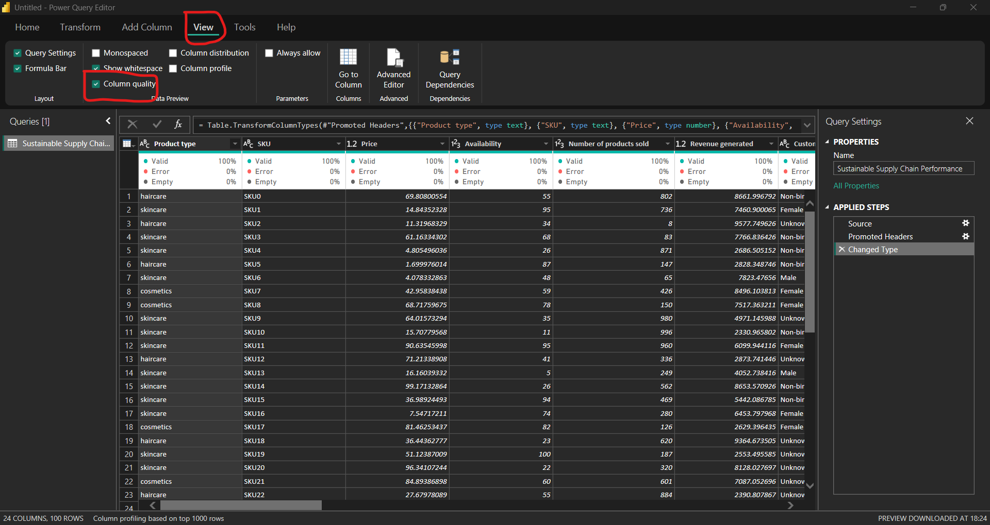

Step 3 : Now create a new table name Inventory which will contain the following columns

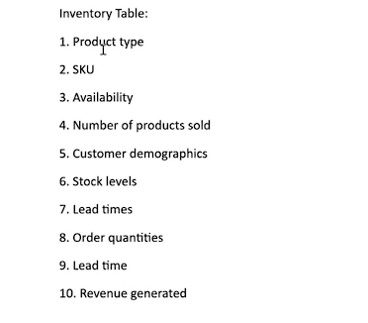

Remove unwanted rows simply by right clicking on the unwanted column

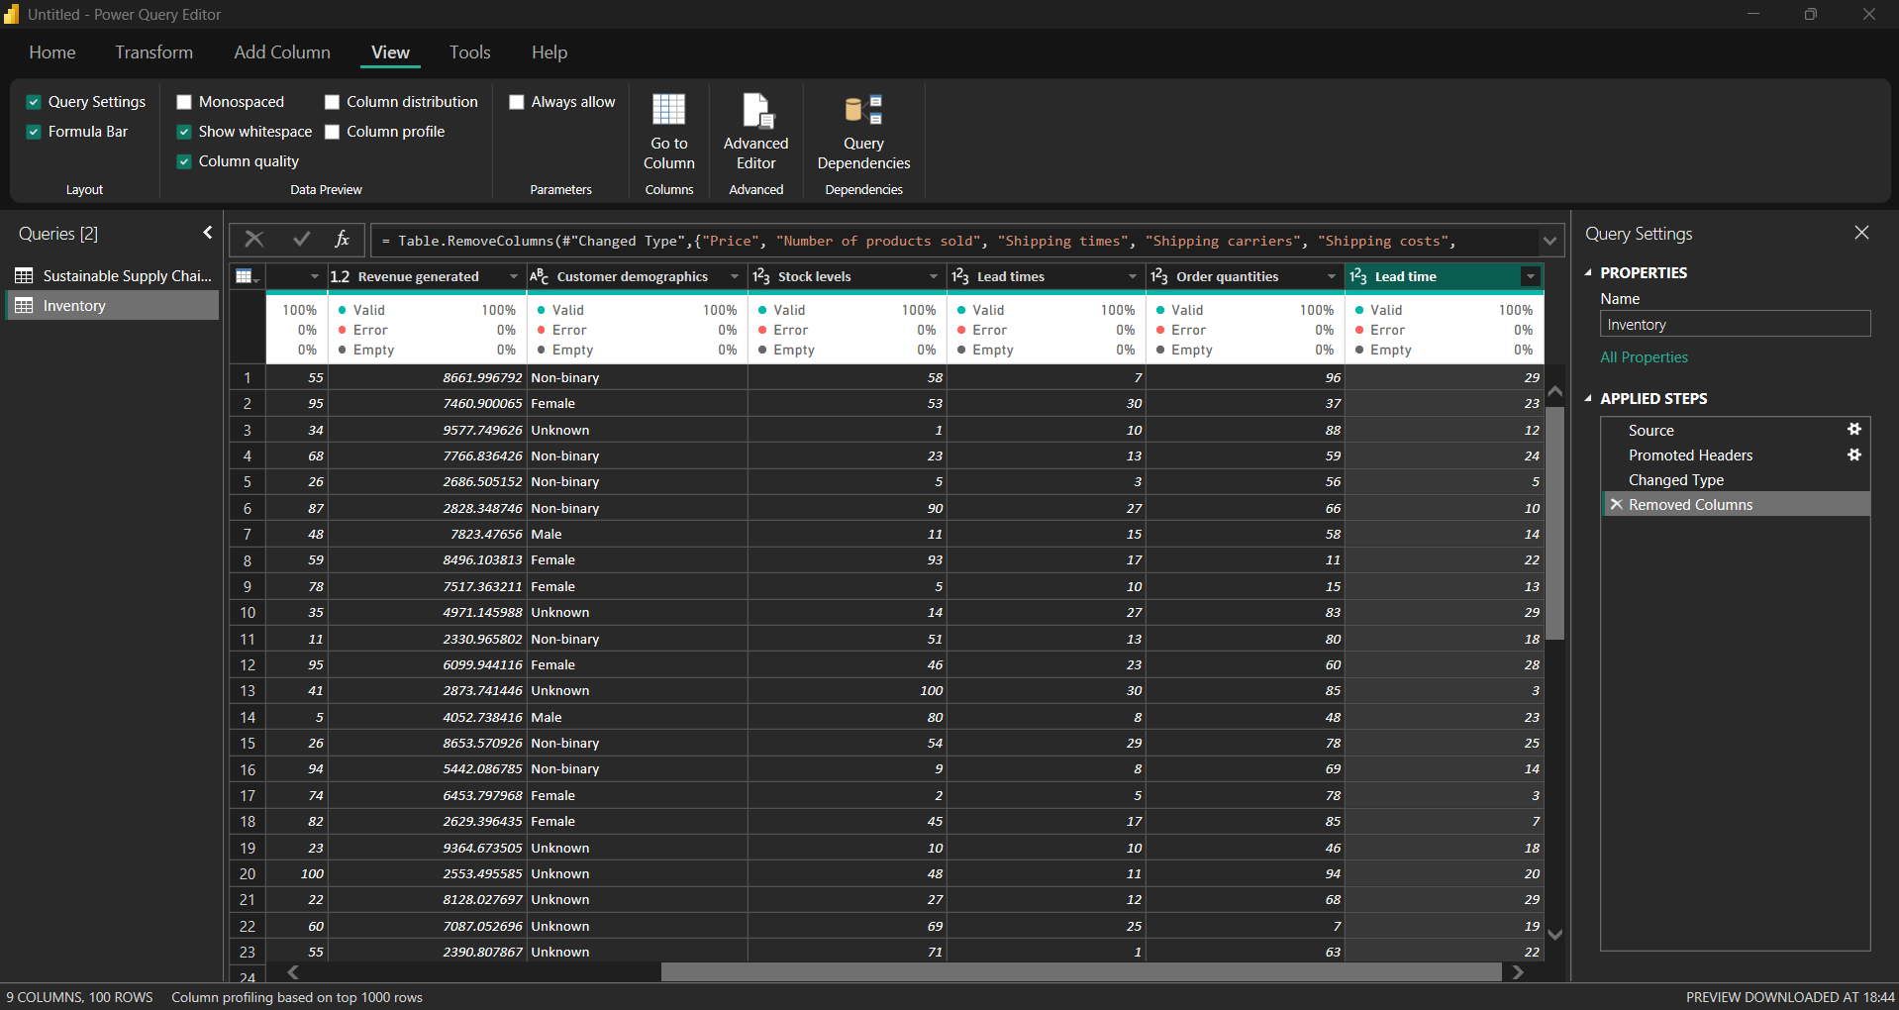

Step 4: Now create a new table name Manufacturing which will contain the following columns

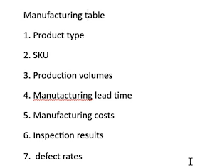

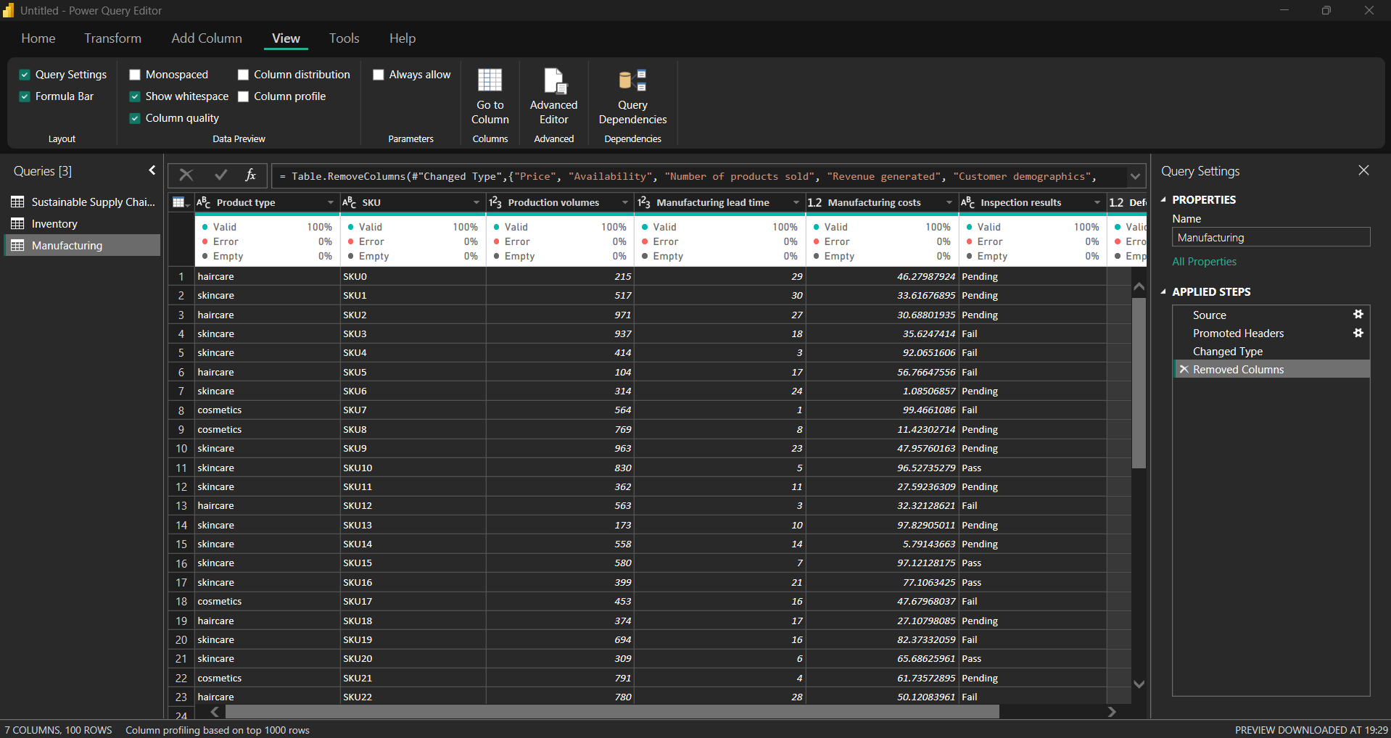

Step 5 : Now create a new table name Supplier which will contain the following columns

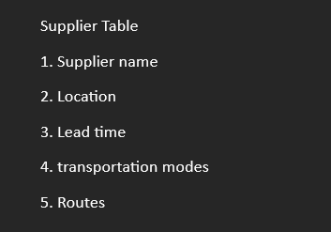

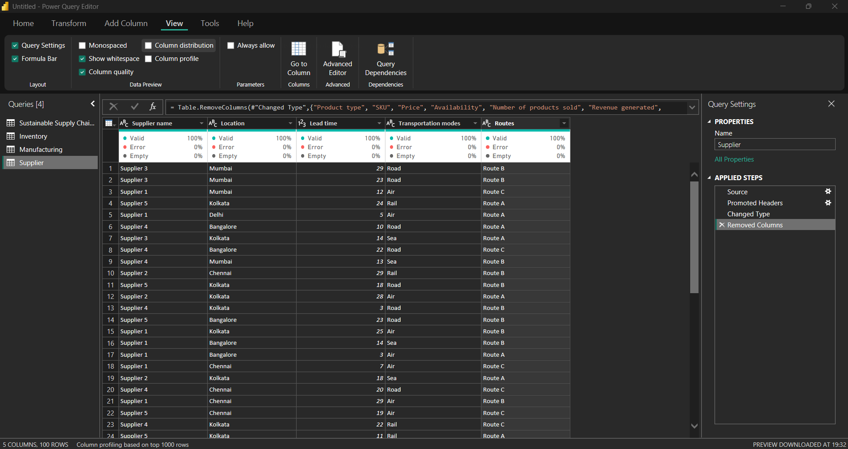

Step 6 : Now create a new table name Supply Chain which will contain the following columns

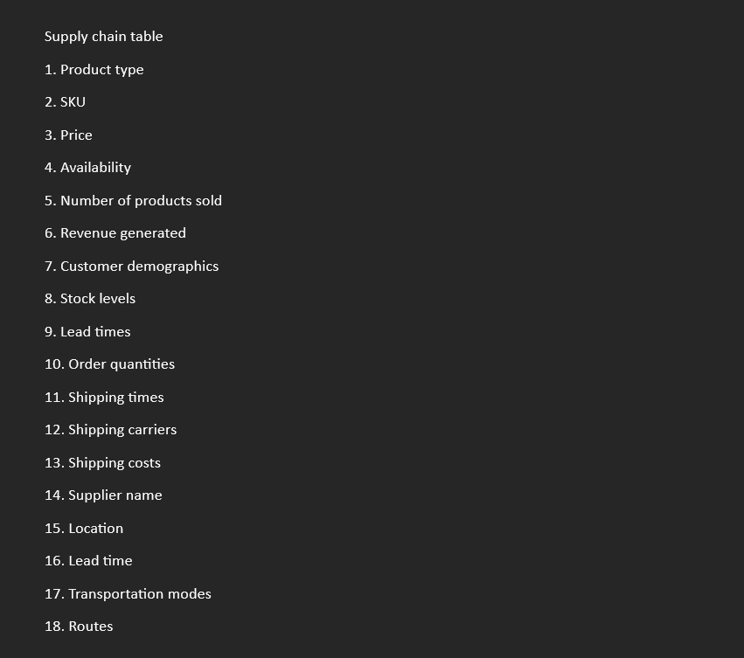

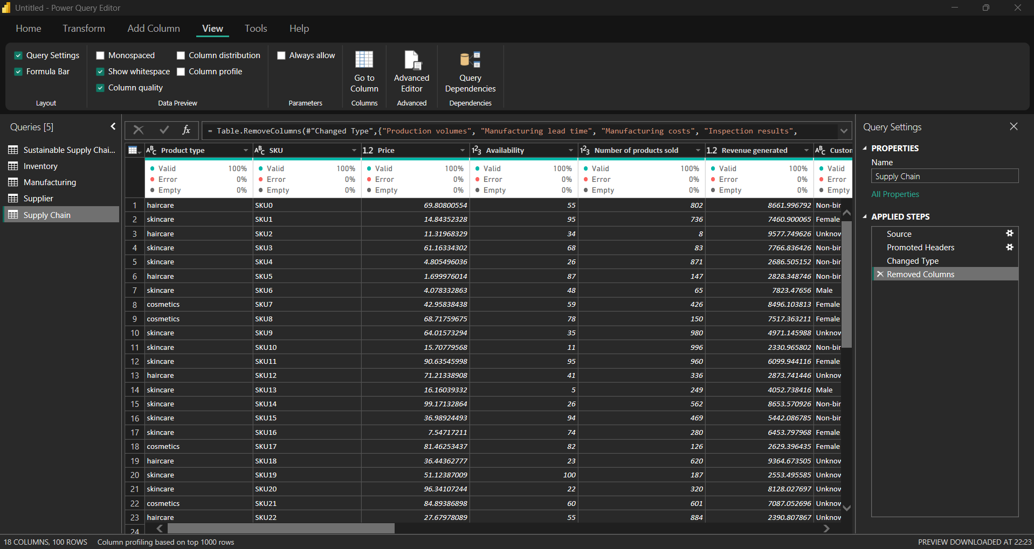

Step 7 : Now to apply these changes to main file go on home tab and Click on close and apply option and save the file